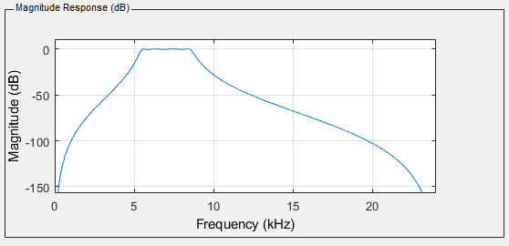

Figure Matlab filter frequency response

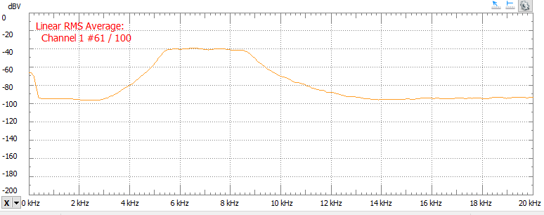

Figure 2 Cascade filter frequency response

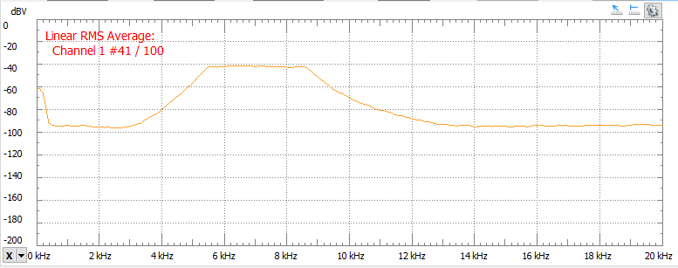

Figure Lattice-Ladder filter frequency response

Cascade.sa

.title "cascade.sa"

.def _cascade

**.sect** ".cascade"

**.global** _cascade

**.global** _cascadeSection

**.global** _filterSections

**.global** _dBuff

**.global** _dOffset

**.global** _sections

**_cascade:** .proc A4, B3 ;cascade(x(n))

.reg x, filter, dBuff, dOffset, sections, p_filter, p_dBuff, i, count, product, result, gain

;move globals into registers

mvk 0, i

mv A4, x

mvkl _dBuff, dBuff

mvkh _dBuff, dBuff

mvkl _filterSections, filter

mvkh _filterSections, filter

mvkl _dOffset, dOffset

mvkh _dOffset, dOffset

mvkl _sections, sections

mvkh _sections, sections

ldw *dOffset, dOffset

ldw *sections, sections

;loop over every section for cascade

**loop:**

mpy i, 4, count ;[i][4]

addaw dBuff, count, p_dBuff ;&dBuff[i][0]

mpy i,7,count ;[i][7]

addaw filter, count, p_filter ;&filterSections[i][0]

.call x = _cascadeSection(x,p_dBuff,dOffset,p_filter) ;get output of single section

**add** i, 1, i

**sub** i, sections, count

[count] b loop

;apply output gain

mpy sections, 7, count ;[i][sections]

addaw filter, count, p_filter ;obtain address of output gain

ldw *p_filter, gain ;load the output gain

mpysp x, gain, x

mv x, A4 ;return result

.endproc A4, B3

b B3

CascadeSection.sa

.title "cascadeSection.sa"

.def _cascadeSection

**.sect** ".cascade"

**.global** _cascadeSection

**_cascadeSection:** .proc A4, B4, A6, B6 ;cascadeSection(x(n),*dBuff(n=0),dOffset,filterCoef)

.reg x, dBuff, filter, p_a, p_b, a, b, d, product, dresult, yresult, count, dOffset, gain

mvkl 0x3<<16|0x1<<8, count

mvkh 0x3<<16|0x1<<8, count

mvc count,AMR ;make B4 a circular buffer of size 16(4*wordSize)

;move parameters into local registers

mv A4, x

mv B6, filter

mv A6, dOffset

mvk 0,yresult

addaw filter, 4, p_a ;a0 address 4*wordLength

addaw filter, 1, p_b ;b0 address 1*wordLength

addaw B4, dOffset, B4 ;shift D to d(0) in circular buffer

mv B4, dBuff ;store initial d(0) location

;init d_k to x_k

ldw *p_a++, a ;load a0;

mpysp x,a, dresult ;x(n)*a0

addaw p_b,1,p_b

mvk 2, count

;compute a,b*d_k

**dLoop:** ;i=1;i<3;i++

ldw *p_a++, a ;a(i)

ldw *++B4, d ;d(n-i)

ldw *p_b++, b ;b(i)

mpysp d,a, product ;d(n-i)*a(i)

subsp dresult,product,dresult

mpysp d,b,product ;d(n-i)*b(i)

addsp product,yresult,yresult

**sub** count, 1, count

[count] b dLoop

;store d[0], calculate y+=d[0]*b[0]

stw dresult, *dBuff ;store d[0]

ldw *+filter[1],b ;get b0

mpysp dresult, b, product ;d[0]*b[0]

addsp product, yresult,yresult

;output gain

ldw *filter, gain

mpysp yresult, gain, yresult ;y*gain

mv yresult, A4 ;return y

.endproc A4, B3

b B3

LatticeLadder.sa

.title "latticeLadder.sa"

.def _latticeLadder

**.sect** ".lattice"

**.global** _latticeLadder

**.global** _filterLength

**.global** _kVal

**.global** _vVal

**.global** _gOld

**_latticeLadder:** .proc A4,B3 ;latticeLadder(x(n))

.reg fVal,vNew, gNew, p_gOld, gOld, p_vBuff, vVal, p_kBuff, kVal, i, m, pointer, product, output

;move into local registers

mv A4,fVal

mvkl _filterLength, m

mvkh _filterLength, m

ldw *m,m

mvkl _kVal, p_kBuff

mvkh _kVal, p_kBuff

mvkl _vVal, p_vBuff

mvkh _vVal, p_vBuff

mvkl _gOld, p_gOld

mvkh _gOld, p_gOld

mvk 0,output

**sub** m,1,m ;filter_size-1,for 0 index

**loop:**

;load array values

ldw *+p_kBuff[m], kVal ;k_m

ldw *+p_vBuff[m], vVal ;v_m

**sub** m,1,m ;used for g_m-1

ldw *+p_gOld[m], gOld ;g_m-1

;compute f_m-1

mpysp kVal,gOld,product

subsp fVal,product,fVal ;f_m-1=f_m(n)-k_m*g_m-1(n-1)

;compute g_m

mpysp kVal,fVal,product

addsp product,gOld,gNew ;g_m=k_m*f_m-1(n)+g_m-1(n-1)

;compute v_m

mpysp vVal,gNew,product

addsp product,output,output ;y+=g_m*v_m

;store gOld=gNew

**add** m,1,product

stw gNew,*+p_gOld[product] ;gOld[m+1]=gNew

[m] b loop

stw fVal,*p_gOld ;gOld[0]=f0

;compute final f*v0+vOld

ldw *p_vBuff, vVal ;v0

mpysp vVal,fVal,product

addsp product,output, output ;output+=f0*v0

mv output, A4

.endproc A4, B3

b B3